International Journal of Plant Production 1(1): 1-9, 2007  ISSN 1735-6814  ©2007 Gorgan University of Agricultural Sciences and Natural Resources,Iran |   GUASNR  www.ijpp.info

Influence 1-Aminoethoxyvinylglycine hydrochloride and α-Naphthalene Acetic Acid on Fruit Retention, Quality, Evolved Ethylene, and Respiration in Apples

E. Fallahi∗
Professor and Director of Pomology Program, University of Idaho, Parma Research and Extension Center, 29603 U of I Lane, Parma, Idaho 83660, USA
Accepted ……..

Abstract

Effects of 1-aminoethoxyvinylglycine hydrochloride (AVG or Aviglycine HCl or ReTain) and α-naphthalene acetic acid (NAA) on fruit retention, fruit quality, eveloved ethylene, and respiration in ‘Rome Beauty’ and three ‘Delicious’ apple cultivars (Malus domestica Borkh.) were studied. The experimental trees were treated with either AVG, applied at 120 g a.i. per 935 L. ha⁻¹ or NAA, applied at the rate of 10 ppm at 1870 L. ha⁻¹. The AVG treatment was applied four weeks before anticipated harvest date while the NAA treatment was applied 7 days before harvest. In both 'Delicious' and 'Rome' apples, application of AVG maintained fruit retention and firmness but reduced starch hydrolysis, ethylene evolution, and respiration as compared to the NAA treatment. In the later harvests, fruit weights in NAA-treated trees were slightly higher than those treated with AVG. Fruit retention, maturity and quality differences between AVG and NAA treatments were more pronounced as the time past from the commercial harvest dates. Based on this study, application of AVG is more effective than NAA in preventing fruit drop and delaying fruit maturity and thus storage life of apples.

Keywords:Apple post harvest physiology, AVG, fruit drop, NAA, storage life

1. Introduction

Fruit drop prior to harvest is a major source of fruit loss in apples. Pre-harvest drop of apples is caused by a surge in endogenous ethylene at the abscission layer of fruit stem. On the other hand, early harvest of apples will lead to low soluble solids concentration, scald development, and poor over-all fruit quality. Maintaining fruit quality attributes after harvest, particularly fruit firmness and starch is the most important goal of fruit packing houses. Fruit endogenous and evolved ethylene can play a major role in the ripening process, and thus storage life and fruit quality of climactertic fruits such as apples (Fallahi et al., 1985a and 1985b).
The compound 1-aminoethoxyvinylglycine hydrochloride (AVG) is an inhibitor of endogenous ethylene production in apples (Bangerth, 1978). AVG found to retain fruit firmness in apples (Bangerth, 1978 and Wang (1977) and pears (Wang (1977). Williams (1980) reported that AVG increased fruit firmness and fruit set in 'Delicious' and 'Golden Delicious' apples. This compound also increased fruit set of apples (Williams, 1980) and increased the number of productive fruit spurs in trees with “dead spur” disorder (Parish et al., 1994) in the following year.
The objective in this project was to study effects of AVG and NAA on pre-harvest fruit drop, fruit quality, evolved ethylene, and respiration in three 'Delicious' cultivars and 'Rome Beauty' apples.

2. Materials and methods

Four apple orchards were selected in three fruit-growing regions of Idaho, United States, for this study. Three orchards of ‘Delicious’ were selected as follows:
1) ‘Ryan Red Spur Delicious’/M. 7 at Williamson Fruit Ranch in Sunny Slope.
2) ‘Starking Delicious’/M. 7 apple at Symms Fruit Ranch in Sunny Slope.
3) 'Top Red Delicious’/M.7 apple at the Henggeler Orchards in Fruitland.
4) ‘Rome Beauty’/M.7 apple at Henggeler Orchard, in Fruitland.

In each orchard, six different segments of trees, each containing five trees were spayed with either 1-Aminoethoxyvinylglycine hydrochloride (AVG or Retain) or α-Naphthalene acetic acid (NAA-800, abbreviated as NAA). Retain was sprayed at the rate of 120 grams a.i. (AVG), mixed with 0.1% (v/v) ABG-7011 surfactant, at 935 L.ha⁻¹ about four weeks before anticipated harvest time. α-Naphthalene acetic acid was applied at the rate 10 ppm at 1870 L.ha⁻¹ about 7 days before anticipated harvest time. Both AVG and NAA were applied with air blast sprayers. In each cultivar, two trees in the middle of each segment were tagged and used for this study (total of 12 trees/cultivar per treatment). Thus, the experimental design for each cultivar was a complete randomized design with six 2-tree replications per treatment. Trees were trained to the central leader system. Other than the AVG treatment, all cultural practices were applied in a manner consistent with those of commercial apple orchards.
The existing fruits under the trees were completely removed before application of chemicals. The dropped fruits under each tree were counted and discarded once a week from the beginning of the experiment until several weeks after anticipated harvest. The anticipated commercial harvest dates were on 25 Sept. for ‘Ryan Spur Delicious’ and ‘Starking Delicious’ and on 30 Sept. for ‘Top Red Delicious’ and on 2 Oct. for ‘Rome Beauty’ apples. Each week, 10 fruits per tree from each treatment were sampled randomly and transported to the University of Idaho Pomology Laboratory in Parma, Idaho for a complete maturity and quality evaluations. Crops of these trees were not harvested at commercial time. This allowed us to continue our fruit drop and fruit quality evaluations several weeks after normal harvest time. Remaining fruit (yield) from each tree was harvested after completion of the experiment, and total number of fruit per tree at the beginning of the experiment was calculated.
Fruits were weighed and fruit color was visually ranked on a scale of 1 to 5, with 1 = 20% red progressively to 5 = 100% red. Soluble solids concentration (SSC) was measured by temperature-compensated refractometer (Atago N1, Tokyo, Japan). Fruit firmness was measured with a Fruit Texture Analyzer (Guss, Strand, Western Cape, South Africa). Starch degradation pattern (SDP) of equatorial slices of each fruit was recorded by comparison with the SDP standard chart developed for apples (Bartram et al., 1993).
To evaluate the effect of AVG and NAA on fruit internal maturity, five apples from each tree were weighed and then placed in 20 x 28 x 28.5-cm closed chambers. The temperature of the chambers was maintained at 22.8 ºC. Air samples with a constant flow rate of 80 mL·min⁻¹ were drawn from the ripening chambers every 24 h to measure concentrations of evolved ethylene and carbon dioxide (CO₂) by gas chromatography. Samples were injected onto a gas chromatograph (Hewlett Packard 5890 Series II, Lionville, Pa.) equipped with a flame ionization detector and a HayeSep Q, 80/100 packed column (Alltech Inc., Deerfield, Ill.).
Assumption of normality was checked by computing univariate analyses for all treatments of this study. All data, including percentages and ratings were normally distributed. Data were analyzed by general linear analysis (GLM) and a T-Test (P ≤ 0.05) using SAS (SAS Institute Inc., Cary, N.C.).

3. Results and Discussion

Results are presented in Tables 1-3 and Figures 1-8. In all apple cultivars, the total number of fruit before the start of the experiments in trees receiving AVG was statistically similar to those receiving NAA (Tables 1 and 3). This is ideal, as the experiments needed to start with a similar crop load in both treatments. Percentages of fruit drop in AVG-treated trees were significantly lower than those in NAA treated trees at all sampling times for all ‘Delicious’ cultivars and ‘Rome Beauty’ (Tables 1 and 3). With the exception to ‘Top Red Delicious’ apple, fruit weight was not affected by treatments during early sampling dates (Tables 1 and 3). In the later harvests, however, fruit weights of NAA-treated trees in all cultivars were slightly higher than those treated with AVG (Tables 1 and 3). This is an indication that AVG may delay fruit maturity attributes, including fruit size. In addition to the direct maturity effect, the late season fruit size increase in NAA-treated trees could in part be due to a crop load effect. In various experiments, including the “Idaho Apple Maturity Project,” we have found that fruit size of certain apples can significantly increase in late August and during September due to a reduction in the heat stress. Since fruit drop in NAA was significantly higher, fewer fruit remained on the NAA-treated trees, leading to a higher leaf to fruit ratio (less fruit-to-fruit competition) and larger fruit size in NAA-treated trees as compared to AVG-treated ones (Tables 1 and 3)
Fruit color was not affected by AVG or NAA applications in most sampling dates (Tables 1 and 3). Fruit color in the NAA-treated ‘Rome Beauty’ trees in two sampling dates was better than that of AVG-treated trees (Table 1), which could be due to the advanced maturity fruit in the NAA-treated trees. In ‘Ryan Spur’ Delicious and ‘Rome Beauty’ apples, fruit from trees treated with AVG often had higher firmness than those treated with NAA at different samplings (Table 2). As compared to NAA, application of AVG reduced fruit SSC in all ‘Delicious’ cultivars, although differences were not always significant (Tables 2 and 3). However, AVG did not affect fruit SSC in ‘Rome Beauty’.
The largest impact of AVG was on fruit SDP, evolved ethylene, and respiration in all apple cultivars tested in this study. Fruits from trees receiving AVG had lower SDP, evolved ethylene, and respiration as compared to those receiving the NAA application in all cultivars (Tables 2, 3 and Figures 1-8). ‘Delicious’ cultivars treated with AVG treatment had significantly lower fruit water core as compared to those treated with NAA (data not shown).

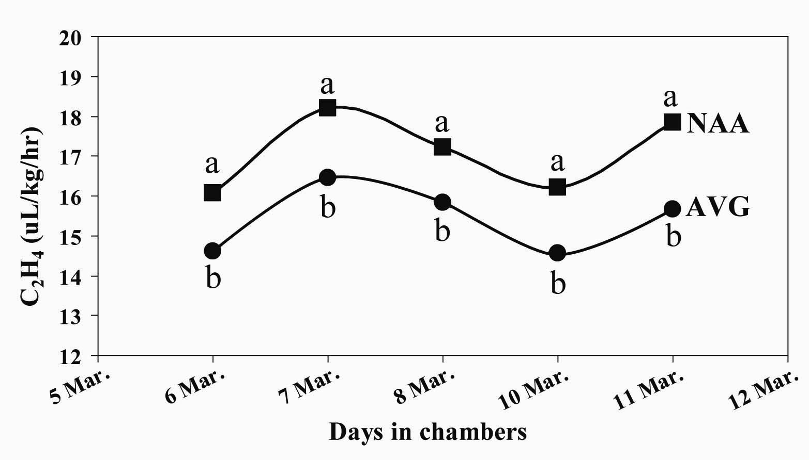
Fig 1. Effects of AVG and NAA on fruit evolved ethylene in 'Ryan spur Delicious' Apple.
Mean separation within each date by a T-test at 5% level.
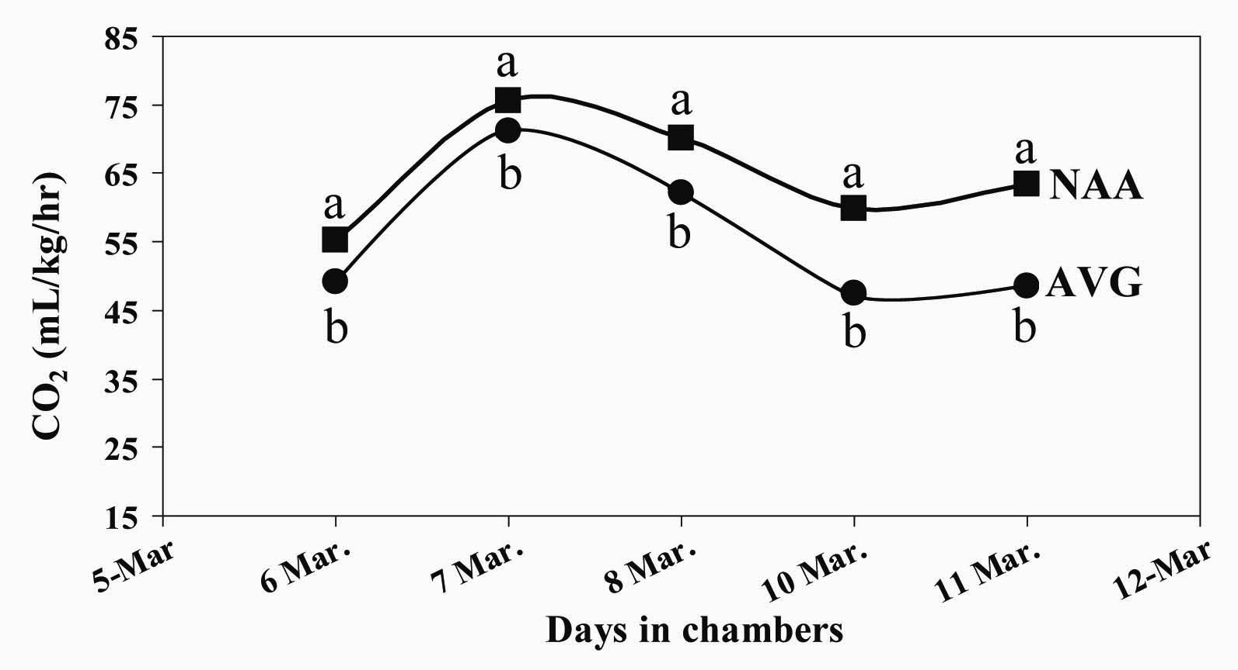
Figure 2. Effects of AVG and NAA on fruit respiration in ‘Ryan Spur Delicious’ apple.
Mean separation within each date by a T-test at 5% level.

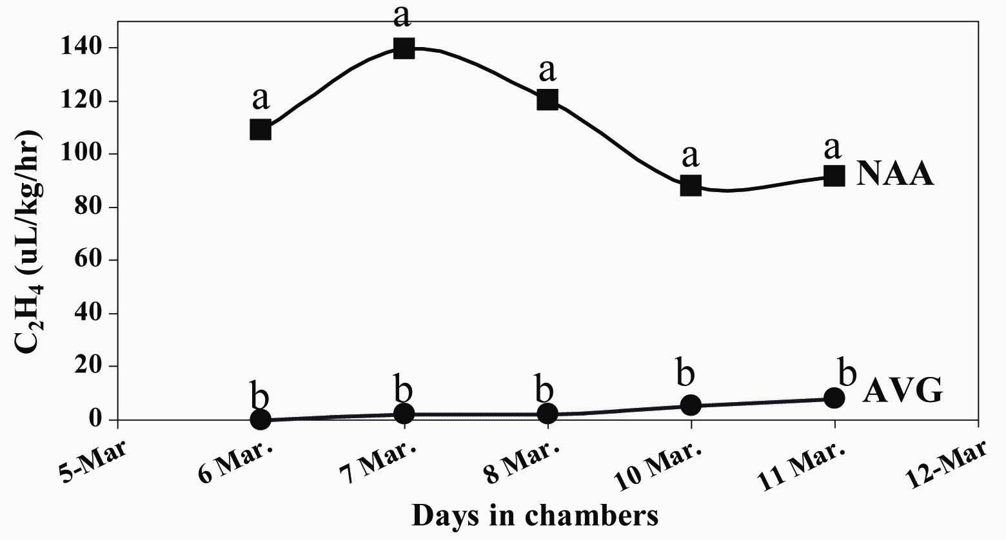
Fig. 3. Effects of AVG and NAA on fruit evolved ethylene on 'Starking Delicious' apple.
Mean separation within each date by a T-test at 5% level.
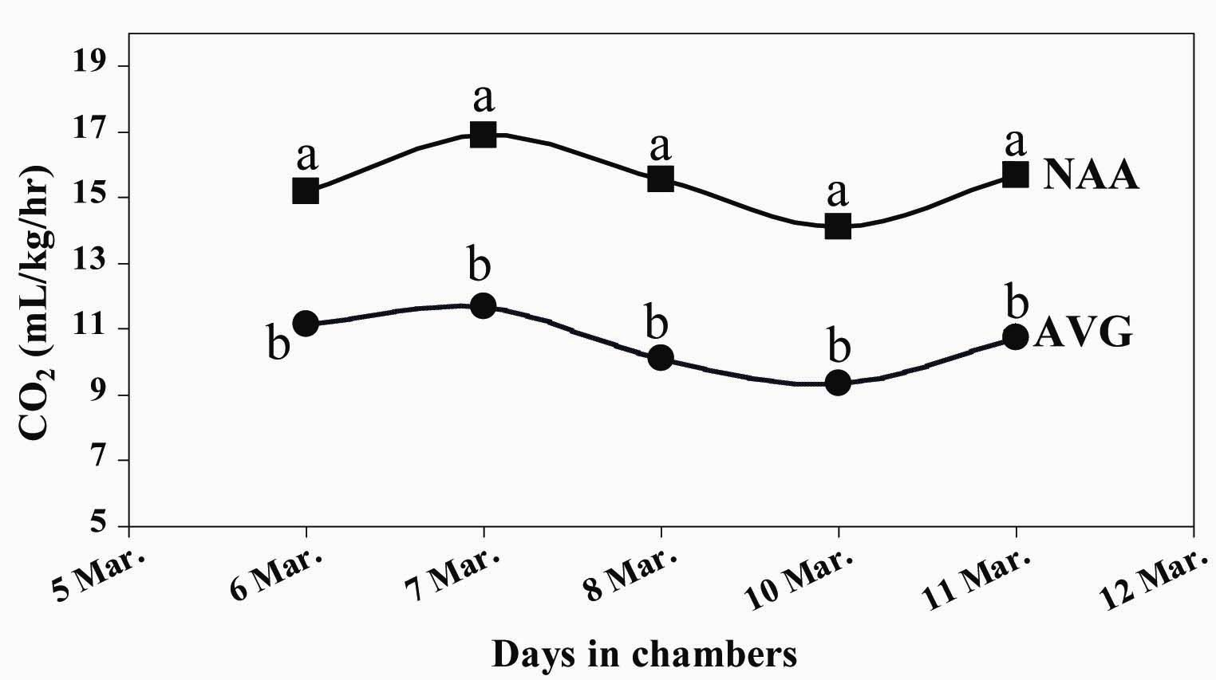
Fig. 4. Effects of AVG and NAA on fruit respiration in 'Starking Delicious' apple.
Mean separation within each date by a T-test at 5% level.

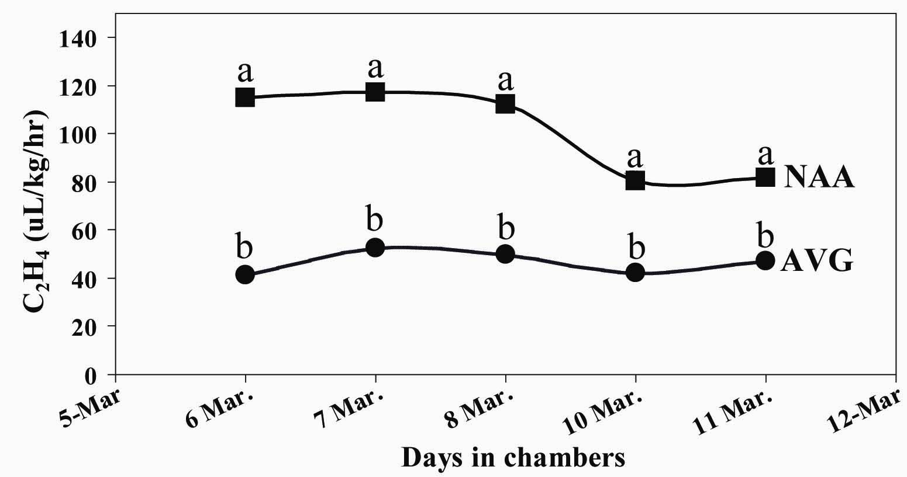

Fig. 5. Effects of AVG and NAA on fruit evolved ethylene in 'Top Red Delicious' apple.
Mean separation within each date by a T-test at 5% level.

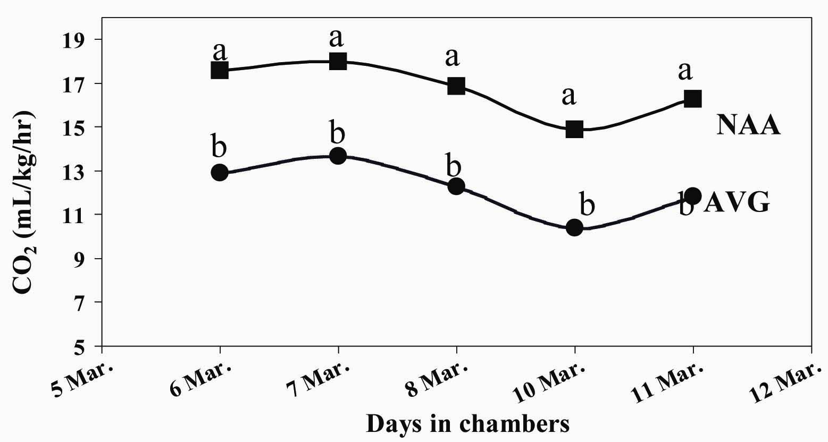

Fig. 6. Effects of AVG and NAA on fruit respiration in 'Top Red Delicious' apple
Mean separation within each date by a T-test at 5% level.

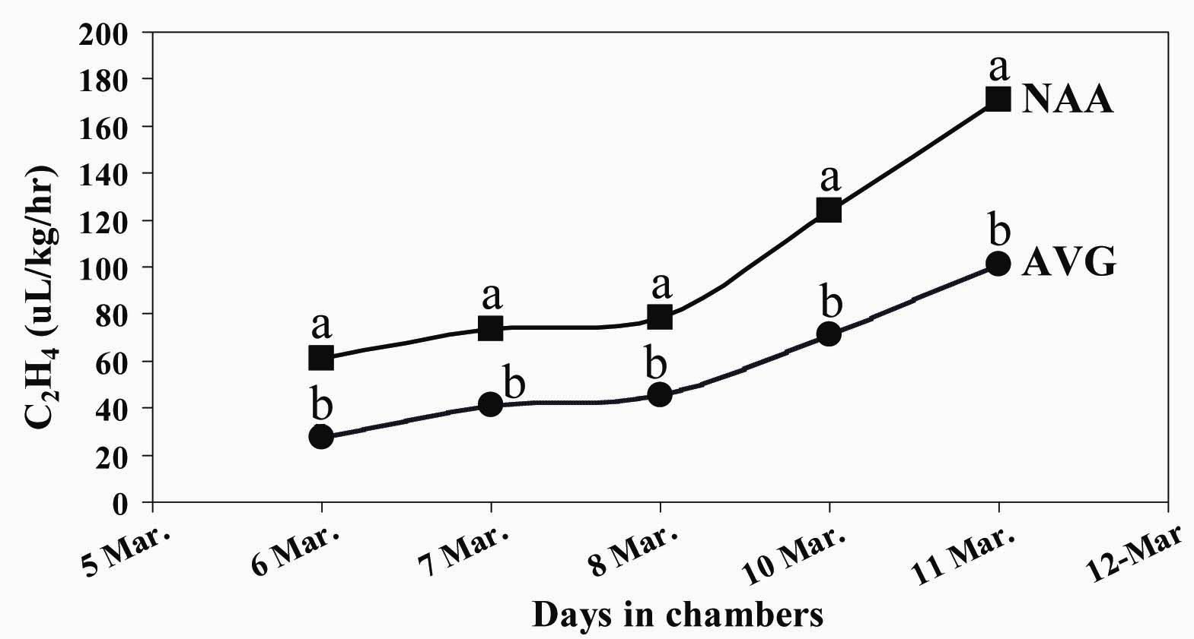
Fig. 7. Effects of AVG and NAA on fruit evolved ethylene in 'Rome Beauty' apple.
Mean separation within each date by a T-test at 5% level.

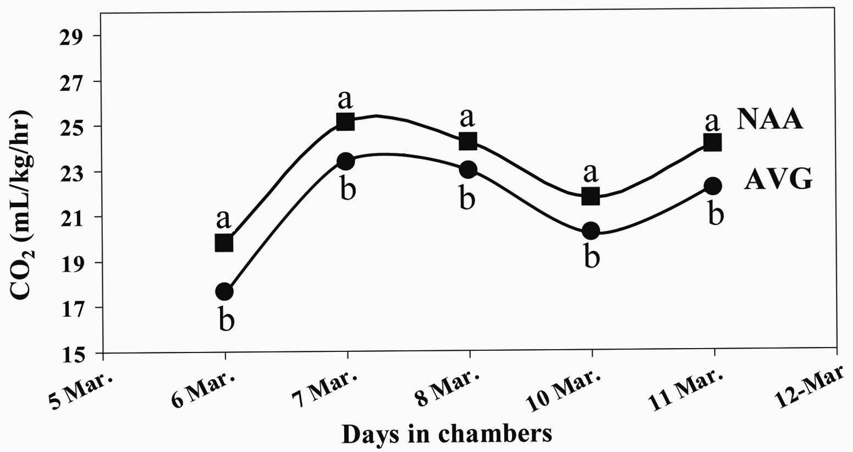

Fig. 8. Effects of AVG and NAA on fruit respiration in 'Rome Beauty' apple.
Mean separation within each date by a T-test at 5% level.
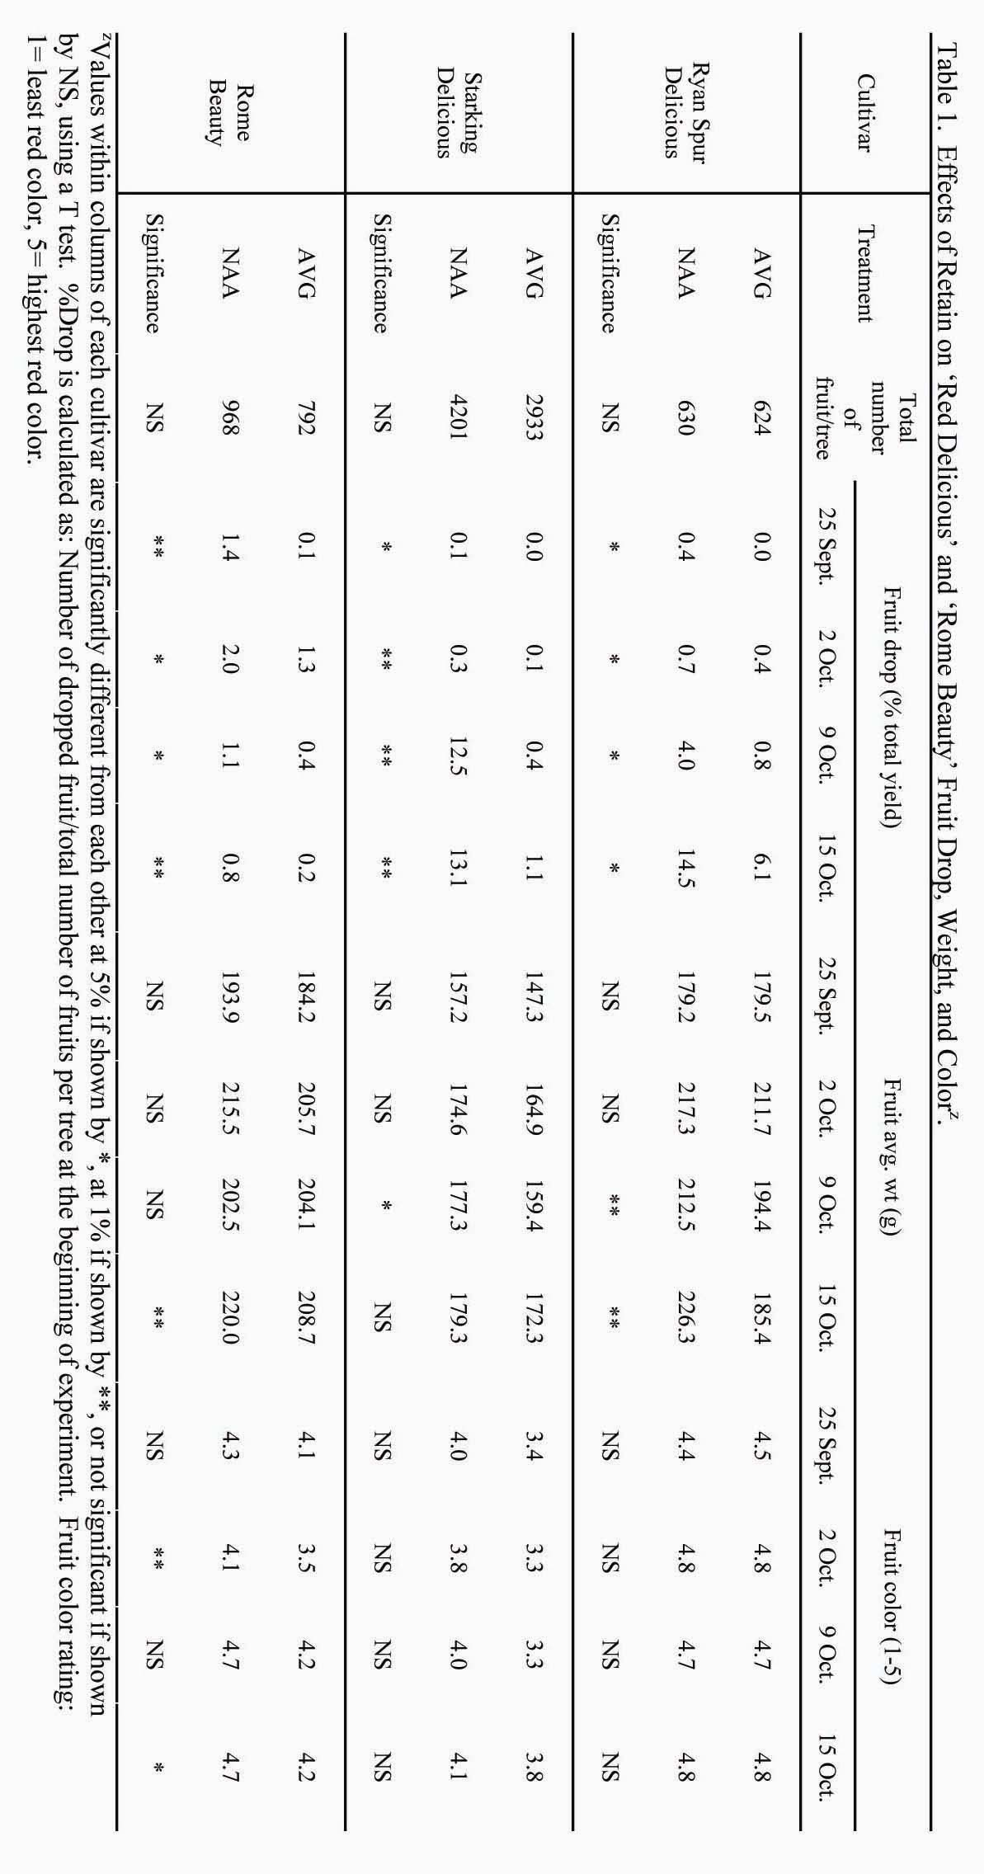
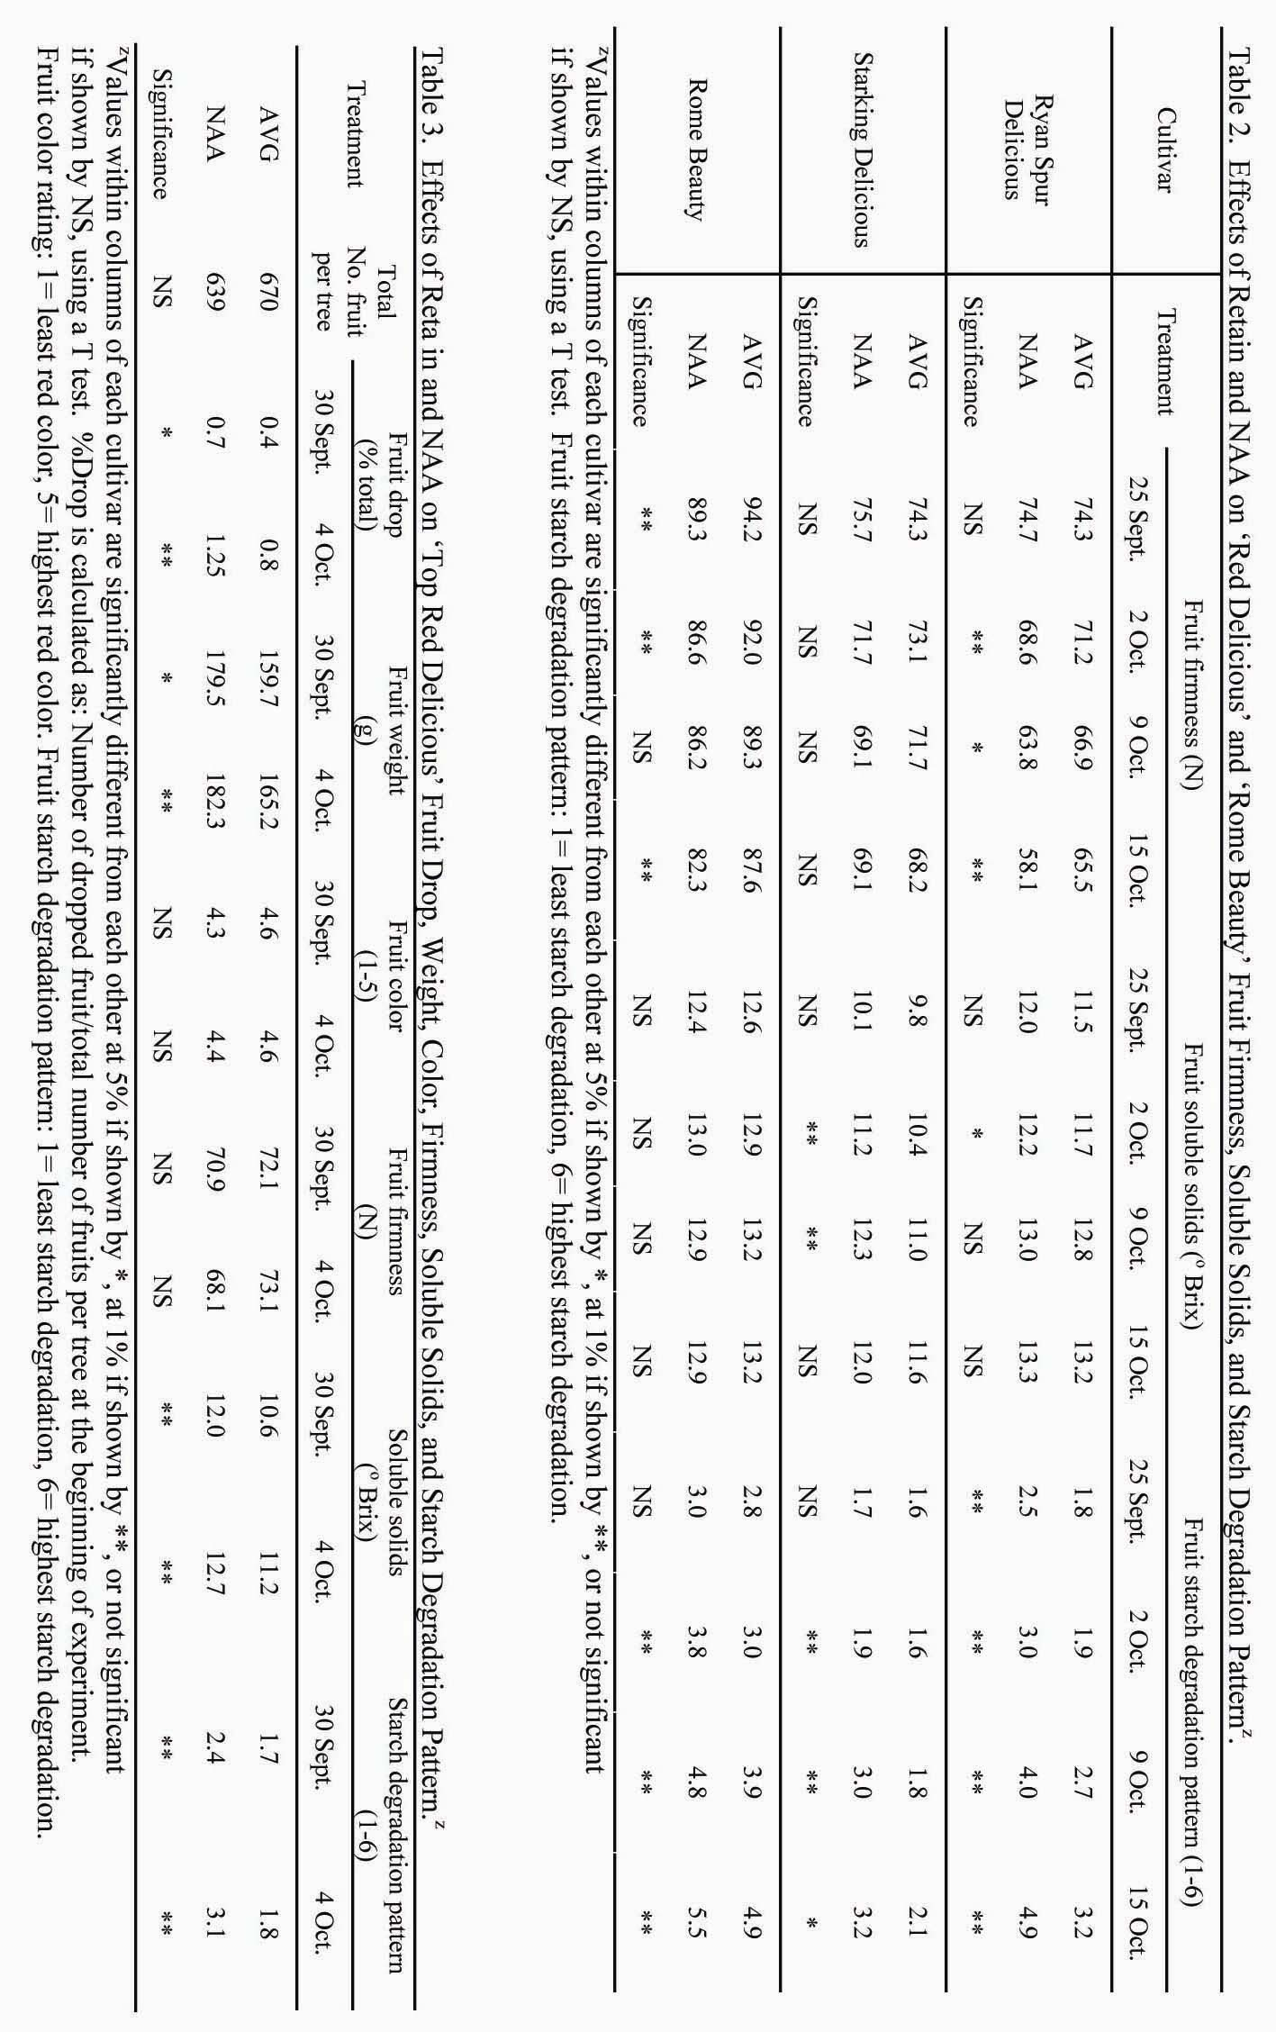

4. Conclusion
Fruit retention, maturity and quality attributes in this study indicate that AVG delays fruit maturity in both ‘Delicious’ and ‘Rome Beauty’ apples. This delay is caused by retarding ethylene evolution and respiration. Based on the results of this study, application of Retain at 120 g. a.i. at 935 L.ha⁻¹ is essential for reducing pre-harvest drop and retaining fruit starch and firmness, and thus postharvest life of apples in medium to long-term cold storages.

References

Bangerth, F. 1978. The effect of substituted amino acid on ethylene biosynthesis, respiration, ripening and preharvest drop of apple fruits. J. Amer. Soc. Hort. Sci. 103:401-404.
Bartram, R.D., W. Bramlage, E.M. Kupferman, K.L. Olsen, M.E. Patterson, and J. Thompson. 1993. Apple Maturity Program Handbook. U.S.D.A.-ARS Tree Fruit Research Station, Wenatchee, Wa.
Fallahi, E., D. G. Richardson and M. N. Westwood. 1985a. Influence of Rootstocks and Fertilizers on Ethylene in Apple Fruit During Maturation and Storage. Journal of the American Society for Horticultural Science, 110(2):149-153.
Fallahi, E., D. G. Richardson, M. N. Westwood and M.H. Chaplin. 1985b. Relationships Among Mineral Nutrition, Ethylene and Postharvest Physiology in Apples on Six Rootstocks. Scientia Horticulturae, 25:163-175.
Parish, C.L., E.A. Stahly, and M.W. Williams. 1994. Effects of an Ethylene Inhibitor, Aminoethoxyvinylglycine, on Dead Spur Type Red Delicious Apple. Plant Disease, April: 347-351.
Wang, C.Y. and W.M. Mellenthin. 1977. Effect of amino ethoxy analog of Rhizobitoxine on ripening of pears. Plant Physiol. 59: 546-549.
Williams, M.W. 1980. Retention of Fruit Firmness and increase in vegetative growth and fruit set of apples with aminoethoxyvinylglycine. HortScince. 15(1): 76-77.

 Corresponding author. Email: efallahi@uidaho.edu

